
Land Information Ontario (LIO) Warehouse
Data Class Name: Forest Cover
Documentation
Produced by: Information Access and Information Management Policy Unit
Ministry of Natural Resources and Forestry
Date: July 27, 2015

Purpose

This document provides additional information to support the use of geospatial data. The Physical Model Diagram provides a visual representation of the relationships in the data class. The Data Change History lists all the modelling and access changes that have occurred during the lifecycle of the data class. A data description identifying table and field names is available upon request.

Need Assistance?
Please contact LIO Support at lio@ontario.ca or 705-755-1878 if you require help.

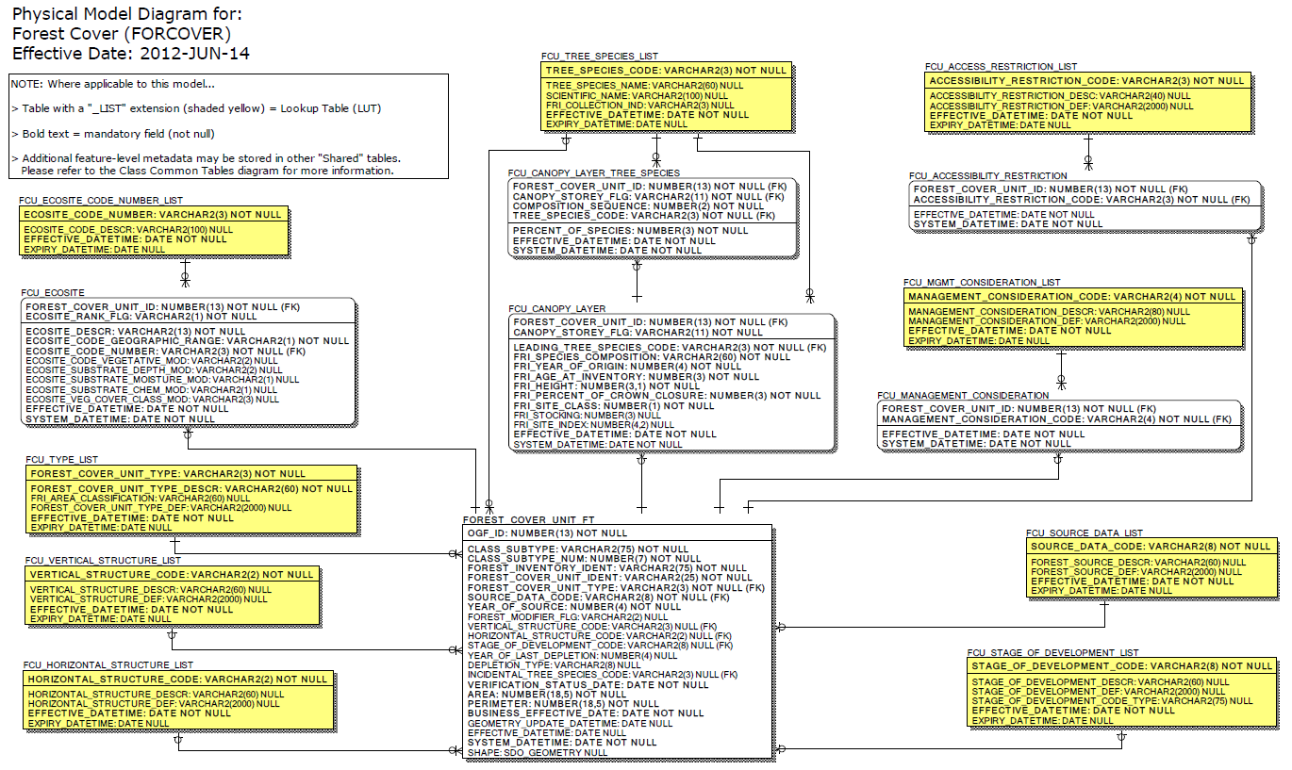
Data Class Change History
Data Class Name: Forest Cover
Data Class Short Name: FORCOVER
Date  YYYY-MM-DD | Details of Change
2009-12-24 | Forest Cover (FORCOVER) data class extensively remodelled.
2004 | FOREST_STAGE_OF_DEV_LIST: Add 3 values to lookup list where Create_Date = 13/07/2006
2004 | NEW Data Class
2004 | FOREST_SOURCE_LIST.FOREST_SOURCE_DEF: Increase Column size from 250 to 500  Clear and reload table
2004 | FOREST_STAGE_OF_DEV_LIST.STAGE_OF_DEVELOPMENT_NAME: Increase Column size from 100 to 200  STAGE_OF_DEVELOPMENT_NAME: Change name to STAGE_OF_DEVELOPMENT_DESCR  STAGE_OF_DEVELOPMENT_DESCR: Change name to STAGE_OF_DEVELOPMENT_DEF  Clear and reload table
2004 | FOREST_ACCESS_RESTRICTION_LIST.ACCESS_RESTRICTION_DESCR: Increase Column size from 20 to 40  Clear and reload table
2004 | WORKING_GROUP_LIST.WORKING_GROUP_DEF: Increase Column size from 75 to 200  Clear and reload table
2004 | FOREST_MGMT_CONSIDERATION_LIST.MANAGEMENT_CONSIDERATION_DESCR: Increase Column size from 60 to 70  MANAGEMENT_CONSIDERATION_DEF: Increase field size from 200 to 500  Clear and reload table
Data Description
Please refer to the metadata record for the data description.

